***The Zeitgeist Project -* AP Literature Final Exam Project**

Directions and Clarifications: This project is designed to apply skills learned in AP Literature and to reflect the rigor of work that will be required in college. This final exam project will count as your final exam grade. The smaller tasks along the way will count as class grades for that particular marking period.

Requirements:

* Read at least 1 fictional novel – this must be a book that is new to you, not a book that was read during your high school career
* Read several non-fiction articles or 1 non-fiction book
* All novel choices must be approved by Ms. Pelrah
* Complete smaller tasks per marking period
* Final paper – 7-10 pages in MLA format
* Final presentation – PowerPoint, Prezi, etc.
* Must be your original work with appropriate textual citations
* Plagiarism = 0%

Focus of the Paper and Presentation:

* Read at least one novel and historical text about a particular era or movement in American History. You might want to focus on the Civil War, World War I/II, Vietnam, the 1960’s, etc. Either choose a novel that interests you and then begin researching related history or choose a time period/historical event and look for a connection to a novel.
* Your goal is to become familiar, via literature, with a particular era or movement of American History. Write a paper in which you demonstrate that the novel/s you read capture the zeitgeist of that particular period. Use the historical text(s) to support, compare and contrast with the novel’s perspective.
* The presentation should capture the thesis and important discoveries that you made while reading and researching. Ideally this presentation will be before peers, teachers and administrators. Details will be finalized as we get closer to the presentation dates.

\*Final paper will be due June 12 (subject to change at the discretion of the teacher)

\*Final presentations will begin June 8 (subject to change at the discretion of the teacher)

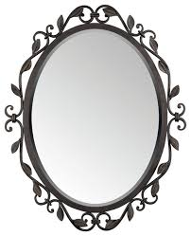

Exploring literature as the mirror for society